# Printing stickers for whiteboard

1. Run Excel
2. Enable “Developer” ribbon
3. Click right mouse button on ribbons menu

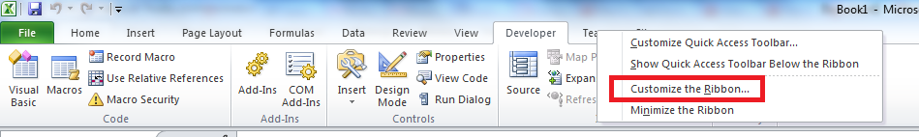

1. Select “Customize the Ribbon…”
2. Select “Developer” checkbox.

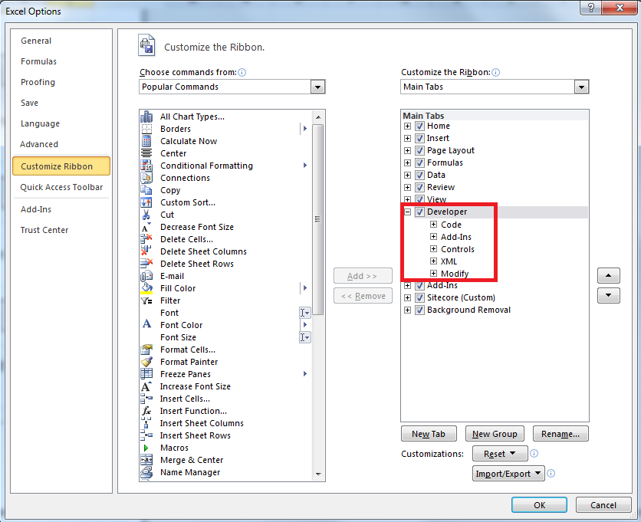

1. Click “Ok”
2. Create macros
3. Click on “Record Macro” button on “Developer” ribbon

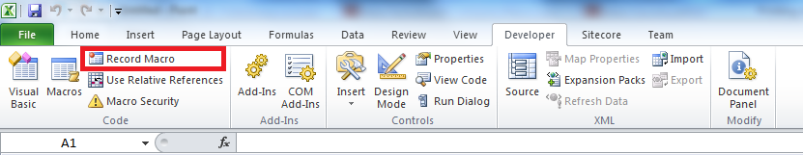

1. Select “Personal Macro Workbook”

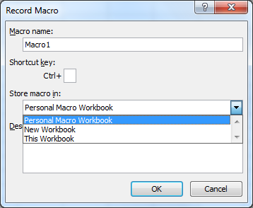

1. Click “Ok”
2. Click on “Stop Recording” button on “Developer” ribbon

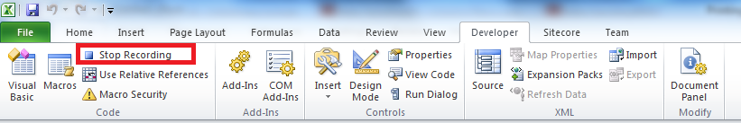

1. Click on “Visual Basic” button on “Developer” ribbon

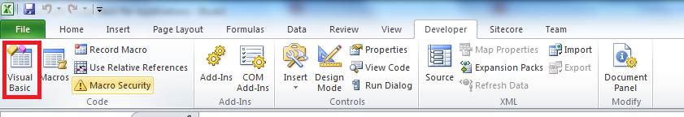

1. Paste to Module 1 in “Personal.xslb” project VB code from attached file(VB_code_v1.txt)

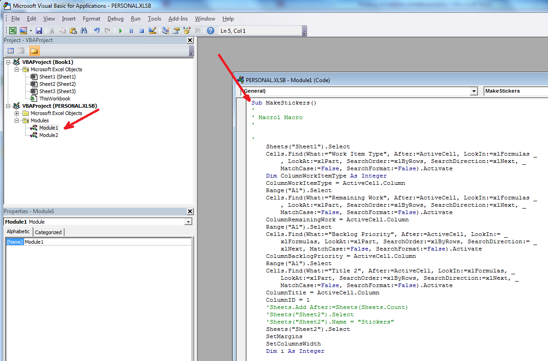

1. Save “Personal.xslb”
2. Create button
3. Click right mouse button on ribbons menu



1. Click “New Tab” button

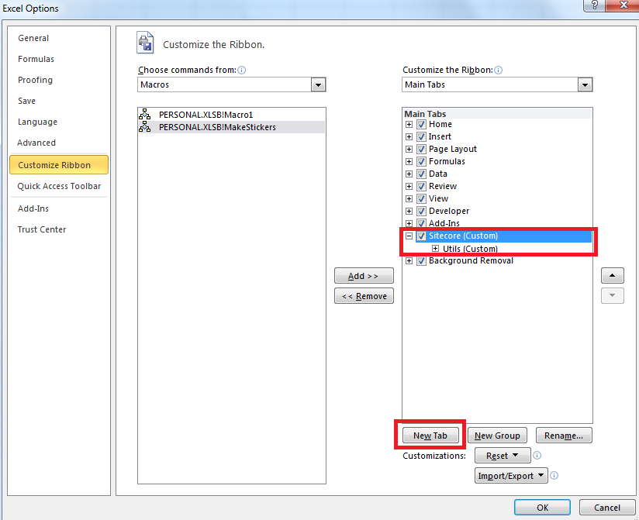

1. Rename tab to “Sitecore”
2. Rename group to “Utils”
3. Add Macro button to ribbon

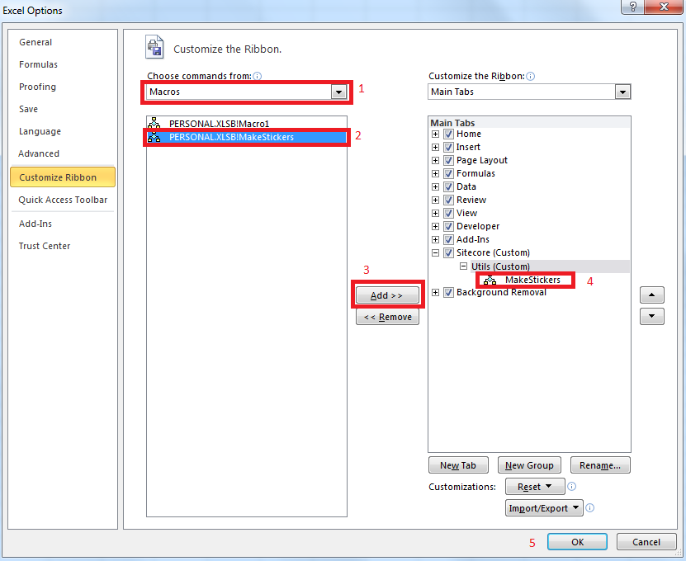

1. Click “Ok” button
2. Macro is ready to use
3. Open Visual Studio
4. Open Sprint Backlog
5. Click “Open Query in Microsoft Excel” button

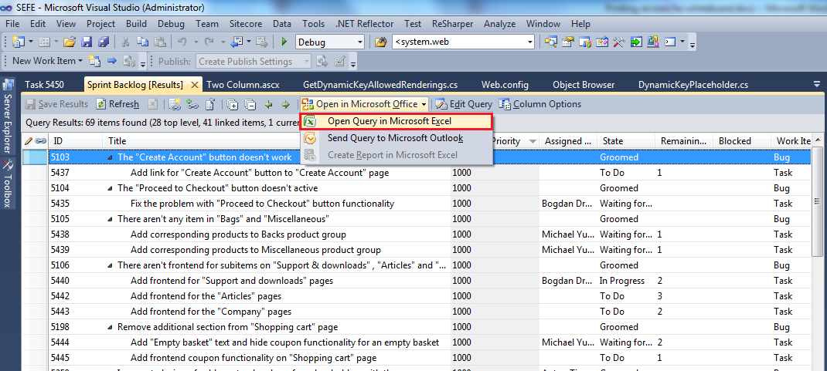

1. Click on “Make Stickers” button

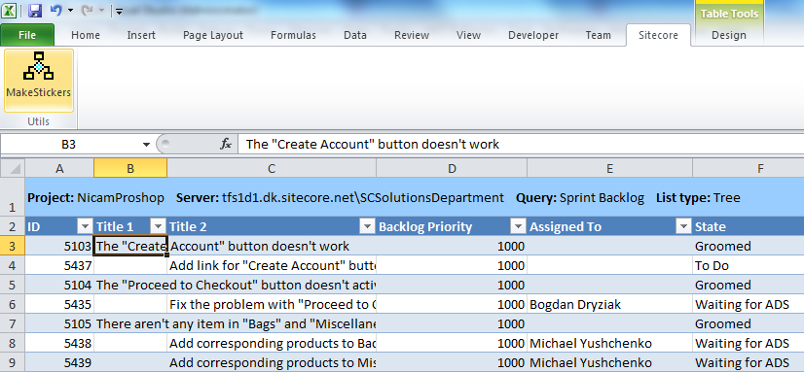

1. After about 1 minute on “Sheet2” are ready stickers for whiteboard
2. Print and cut letter to stickers

**When you will use this macro second time you are able to start from 5 step.**